Ideation Phase
Brainstorm & Idea Prioritization Template
31 January 2025

Date | 30 September 2026
Team ID | SWTID-2026-7613
Project Name | Auto Ticket Classification using Flow Designer
Maximum Marks | 4 Marks

Brainstorm & Idea Prioritization Template:
Brainstorming provides a free and open environment that encourages everyone within a team to participate in the creative thinking process that leads to problem solving. Prioritizing volume over value, out-of-the-box ideas are welcome and built upon, and all participants are encouraged to collaborate, helping each other develop a rich amount of creative solutions.
Use this template in your own brainstorming sessions so your team can unleash their imagination and start shaping concepts even if you're not sitting in the same room.
Reference: https://www.mural.co/templates/brainstorm-and-idea-prioritization
Step-1: Team Gathering, Collaboration and Select the Problem Statement
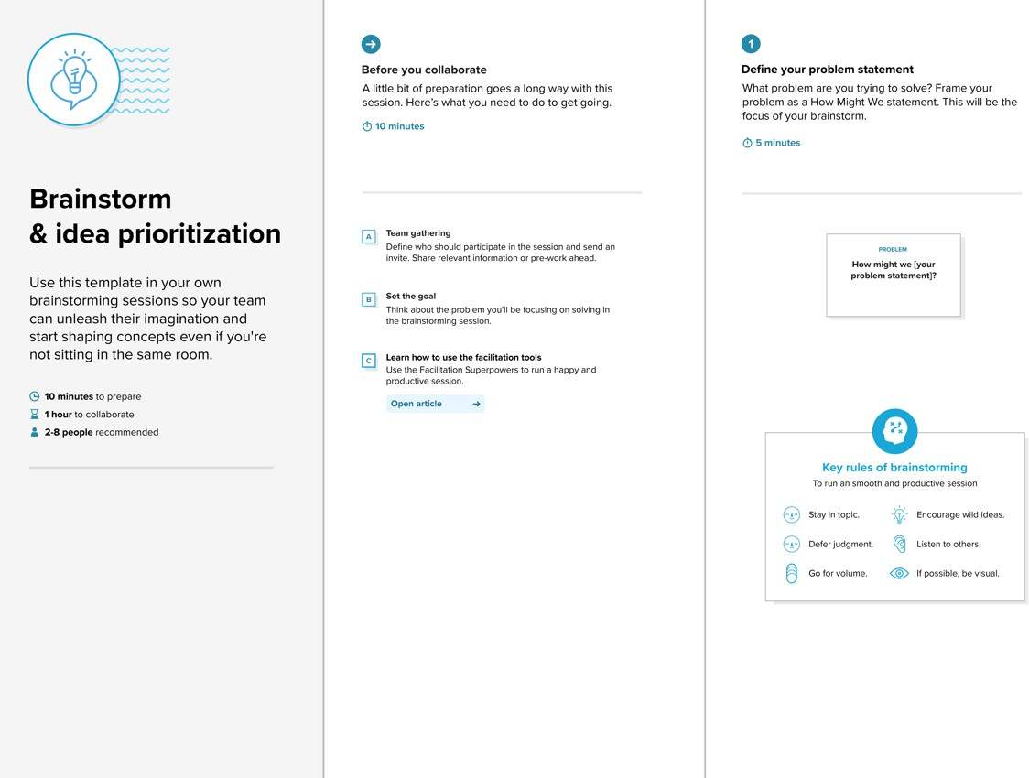
classify school IT tickets at creation to reduce manual effort and improve routing?
How might we automatically

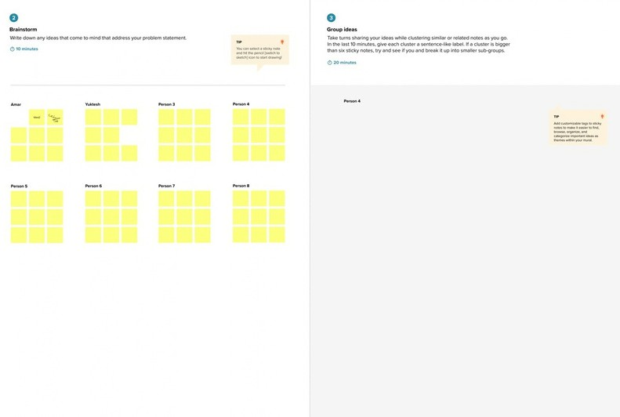






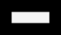


Step-2: Brainstorm, Idea Listing and Grouping
Vijay Ragavan S
Kirubakaran S
Dinesh B
Sadasivakrishnan R S
Vijay Ragavan S
classify match Network
Auto Keyword WiFi →
Email No-code Trigger:
Reduce Faster Easy to
tickets
to caller Flow Category
Designer is empty
manual routing maintain
effort
Update Export Future:
Set XML SLA
Projector Password Slow PC
- Hardware → Access → Perf.
Update Test:
Identify the issue type
from Short Description keywords
+ Subcat.
Category WiFi
Update Category and
Subcategory automatically
ticket
WiFi /
Network
Projector
Network >
Wi-Fi
Hardware >
Projector
Ragulraj H
Password /
Login
Slow /
Hanging
Access >
Forgot Password
Performance >
Slow Computer
send email wi-fi
email message test

projector check
test
email
Confirm submission
to the caller by email
Build it no-code and
keep it maintainable
Confirmation
email sent
Caller notified
of submission
Flow
Designer
No-code
automation
Sent after
classification
Update Set
(export XML)

Step-3: Idea Prioritization
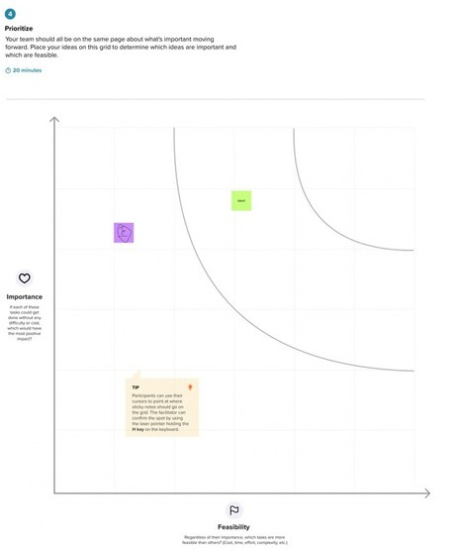

Keyword
auto-classify
Email to
caller
Assign-
ment auto (future)
Predictive
intel. (future)
No-code
Flow Designer
SLA track
(future)
Update Set
deploy

Ideation Phase
PS-1
PS-2
Define the Problem Statements
31 January 2025

Date | 30 September 2026
Team ID | SWTID-2026-7613
Project Name | Auto Ticket Classification using Flow Designer
Maximum Marks | 2 Marks

Customer Problem Statement Template:
Create a problem statement to understand your customer's point of view. The Customer Problem Statement template helps you focus on what matters to create experiences people will love.
A well-articulated customer problem statement allows you and your team to find the ideal solution for the challenges your customers face. Throughout the process, you’ll also be able to empathize with your customers, which helps you better understand how they perceive your product or service.
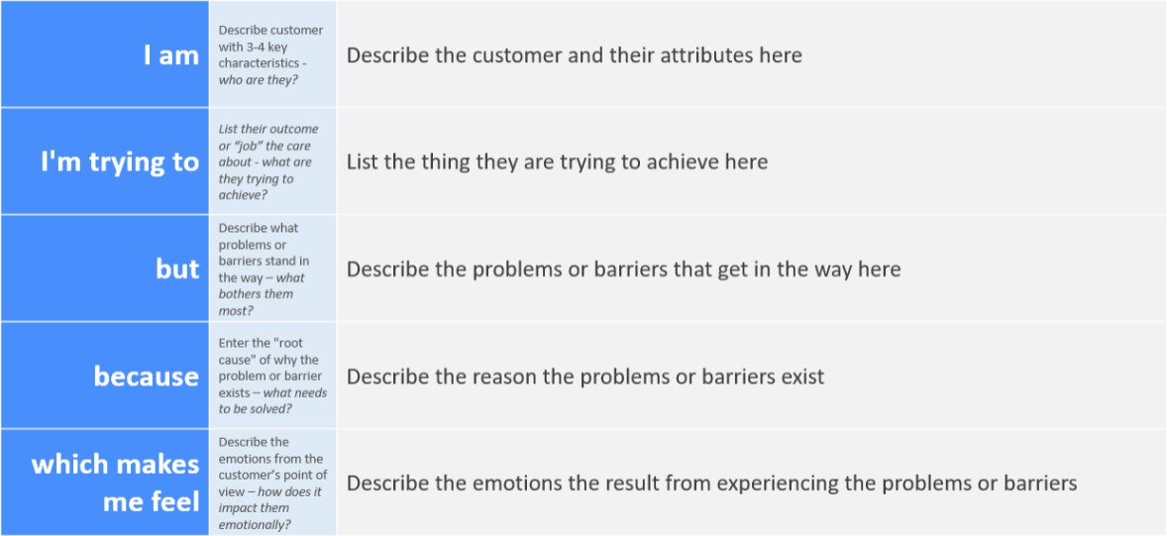
Unsure whether my request was received and frustrated by delays.
There is no automatic classification when a ticket is created, so manual review is time-consuming and inefficient.
IT staff review each request and assign the Category and Subcategory manually.
Get my IT issue reported and routed quickly to the right support team.
A student or teacher at the school who raises IT support tickets (Wi-Fi, projector, password and slow-computer issues).

Reference: https://miro.com/templates/customer-problem-statement/
Example:
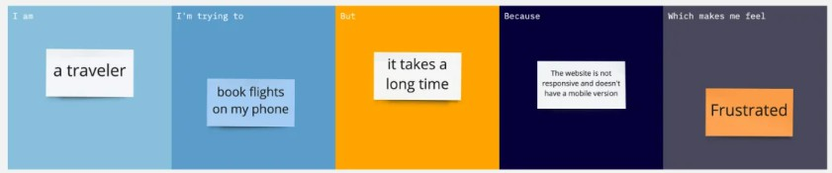

Problem  Statement (PS) | I am  (Customer) | I’m trying to | But | Because | Which makes me feel
PS-1 | A student or teacher who raises IT support tickets | Get my IT issue (Wi-Fi, projector, password, slow computer) reported and routed quickly | IT staff review each request and assign the category manually | Tickets are not classified automatically when they are created | Unsure whether the request was received and frustrated by delays
PS-2 | An IT helpdesk agent who handles incoming incident requests | Classify and route tickets efficiently with minimal manual effort | Reviewing every ticket and setting Category and Subcategory by hand is time-consuming | There is no automation to identify the issue type from the Short Description | Overloaded by repetitive manual work

Ideation Phase Empathize & Discover
31 January 2025

Date | 30 September 2026
Team ID | SWTID-2026-7613
Project Name | Auto Ticket Classification using Flow Designer
Maximum Marks | 4 Marks

Empathy Map Canvas:
An empathy map is a simple, easy-to-digest visual that captures knowledge about a user’s behaviours and attitudes.

It is a useful tool to helps teams better understand their users.
Creating an effective solution requires understanding the true problem and the person who is experiencing it. The exercise of creating the map helps participants consider things from the user’s perspective along with his or her goals and challenges.
Example:
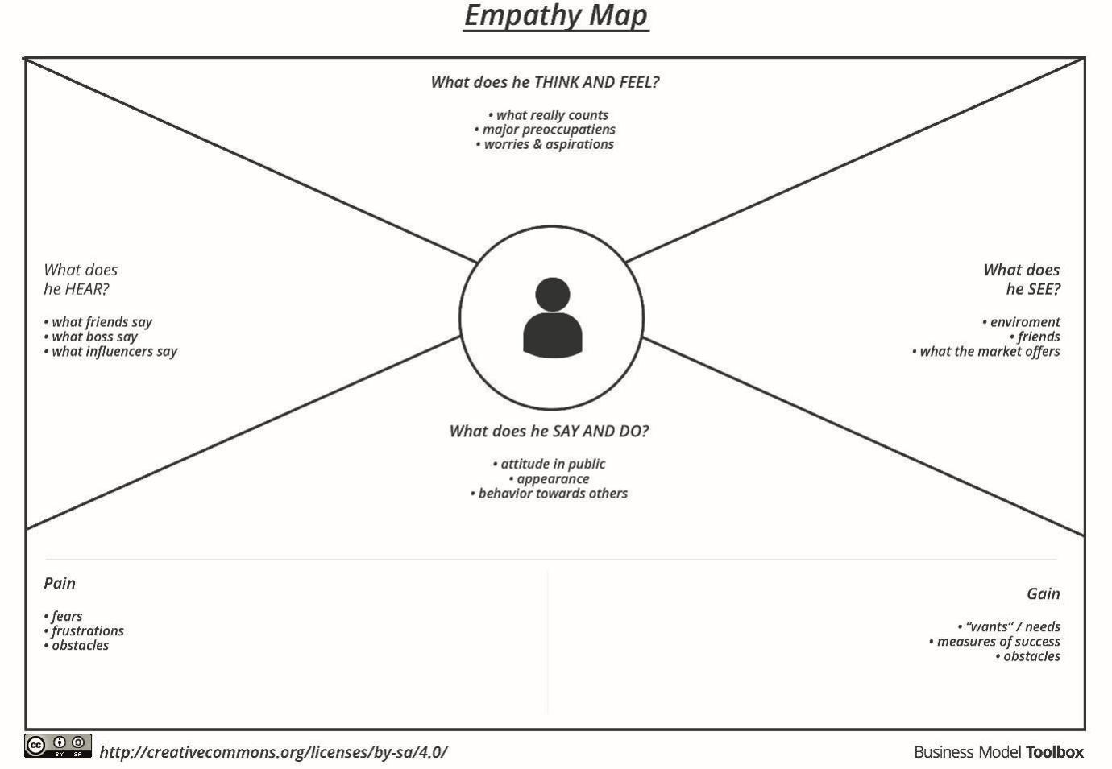
Worried that a request may be delayed or missed; hopes the issue is fixed quickly.
Teachers and students report Wi-Fi, projector, password and slow-computer problems.
Incident form with a Short Description field; confirmation email after submission.
Creates an IT support ticket with a Short Description, e.g. “WiFi not working in library”.
- Manual review makes classification slow and inconsistent
- No confirmation that the request was received
- Category and Subcategory set automatically at creation
- Reduced manual effort for IT agents
- Confirmation email sent to the caller

Reference: https://www.mural.co/templates/empathy-map-canvas

Example: Auto Ticket Classification using Flow Designer
Example: Food Ordering & Delivery Application
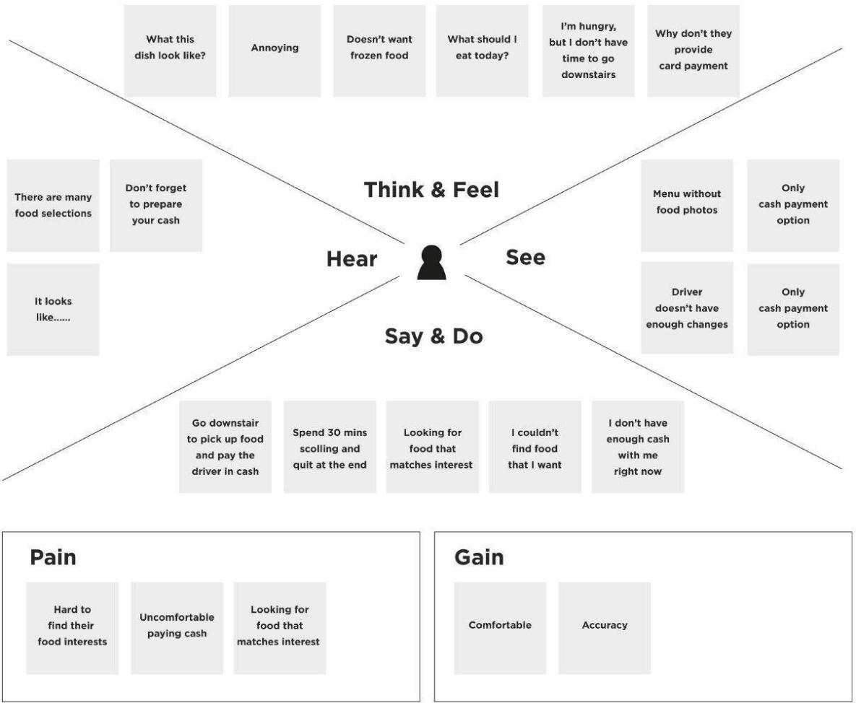

Email confirmation

Auto-classified at creation

No quick confirmation

Inconsistent categories

Manual categorizing is slow

Wait for the IT team

“Projector not turning on”

“WiFi not working in library”

Type a Short Description

Create an IT ticket in Incident Workflow

Category and Subcategory set on ticket

Confirmation email in my inbox

I forgot my password

Tickets wait for a category

IT staff review tickets by hand

Projector failed again

Wi-Fi is down in the library

Did my ticket get submitted?

I need Wi-Fi or projector working now

What should I write in the Short Desc?

I hope it goes to the right team

Frustrated by delays

Will my request be seen?

I T H E L P D E S K
F A I R P L A N E

Auto Ticket Classification using Flow Designer
Guided city tours
Based on the Auto Ticket Classification using Flow Designer project documentation

Student | Teacher | IT helpdesk staff | IT  administrator | Ticket caller

SCENARIO
Claudia Larmon
Menaka Mahajan
Jerome Phillips
Alejandro Flores
Emma Sato

Reporting an IT issue and getting the ticket auto-classified
Browsing, booking, attending, and rating a local city tour

Entice
A student or teacher has an IT problem and decides to contact the school IT helpdesk.
How does someone initially become aware of this process?

Enter
The user opens the IT support ticket form and enters the caller name and short description.
What do people experience as they begin the process?

Engage
The ticket is submitted, Flow Designer checks the short description and assigns Category and Subcategory.
In the core moments in the process, what happens?

Exit
An automated email confirms the request and the ticket is stored with structured details.
What do people typically experience
as the process finishes?

Extend
The solution can be extended with assignment automation, SLA tracking and predictive intelligence.
What happens after the experience is over?

Steps
Visit website or app
Choose a city, dates, and number of people
Browse available tours
View detail on a single tour
Start purchase of a tour
Complete payment information
Confirm payment & book tour
Email confirmation
Email reminder
Arrive at tour location
Meet the guide & group
Experience the tour
Leave the guide & group
Prompt for review
Writing & submitting review
Tour appears in the user profile
Personalized recommendations
Personalized tour offers
Personalized tour suggestions after new travel booking
Booking other travel

More classifications

Predictive intelligence

SLA tracking

Assignment automation

Ticket processed by IT team
Email confirmation received

Email confirmation
Category and subcategory assigned

Automatic classification

Submit ticket

Skip category fields

Add more details

Enter issue description

Enter caller name

Open IT support form

Ready to report

Find IT support form

Go to ServiceNow

Decide to get help

Experience IT problem
What does the person (or group) typically experience?

A student or teacher faces a Wi-Fi, projector, password or slow computer issue

The user decides to contact the school IT helpdesk
The user reaches the ServiceNow portal from a computer or mobile device

The user finds the IT support ticket form to report the issue

Only the caller and a short description of the issue are needed

The user opens a new record on the IT support ticket form

The user enters the caller name on the ticket form
The user types a short description, e.g. WiFi not working in library

The user can add extra detail in the Description field

Category and Subcategory are not selected by the user

The ticket is submitted and Flow Designer is triggered
Flow Designer checks the short description for keywords

Category and Subcategory are set,
e.g. Network → Wi-Fi

An automated email is sent to the caller confirming the request was submitted

The caller receives the confirmation in their email

The ticket is stored with caller, category, subcategory, state and assignment details

Later, tickets could be assigned to IT groups automatically

The solution can be extended with SLA tracking

Predictive intelligence can be added in future

More keywords and ticket categories can be added to the flow
A customer navigates to the city tours section of our website or app
The customer types a city, dates, and the number of people who will attend the tour to see what tours are available
The customer sees available tours for their dates, city, and number of people
After seeing a tour that interests them, the customer clicks or taps to view more. They see information about what and where the tour will cover, plus its price, time of day, and tour guide.
After deciding to go on this tour, they click the Purchase button
They fill out their contact and credit card information, then continue
They see a summary of what they are about to purchase, then they confirm and the tour is booked!
An email immediately sends to confirm their tour and provide details about where and when to meet their guide
One day before the tour begins, a reminder email is sent to all tour participants. The email emphasizes where and when to meet, and what to bring (if applicable).
Using their own means of transportation, the customer makes their way to the tour location at the scheduled time.
Tour participants meet the guide and other people who have joined the same tour
The guide brings the group around the area, explaining things as they go. Typically this lasts about 3 hours.
The guide wraps up the tour and everyone heads their separate ways
One hour after the tour finishes, an email and in-app notification prompt the tour participant for a review
The tour participant writes a review and gives the tour a star-rating out of 5.
The completed tour appears on the "past experiences" area of a customer's profile with a few details on where the group went
Participation in the tour informs our backend recommendation systems, which the customer may experience via better personalization
The customer receives an email 14 days after their tour with personalized recommendations for other tours
When a past tour participant books new travel with us, we show them personalized tour recommendations in their arrival city.
Most customers discover city tours as they are booking other Fairplane travel

Interactions
Travel booking section of the website, iOS app, or Android app
City tours section of the website, iOS app, or Android app
City tours section of the website, iOS app, or Android app
City tours section of the website, iOS app, or Android app
City tours section of the website, iOS app, or Android app
City tours section of the website, iOS app, or Android app
Payment overlay within the website, iOS app,
or Android app
Payment overlay within the website, iOS app,
or Android app
Customer's email (software like Outlook or website like Gmail)
Customer's email (software like Outlook or website like Gmail)
Tour locations tend to start in a specific public space (e.g. the steps of a statue in a town square)
Direct interactions with the guide, and potentially other group members
Direct interactions with the guide, and potentially other group members
Direct interactions with the guide, and potentially other group members
Customer's email (software like Outlook or website like Gmail)
“Leave a review” modal window within the profile on the website, iOS app, or Android app
Completed experiences section of the profile on the website, iOS app, or Android app
Recommendations span across website, iOS app, or Android app
Customer's email (software like Outlook or website like Gmail)
Post-purchase screens website, iOS app, or Android app

Category and Subcategory choice lists

ServiceNow with predictive intelligence

ServiceNow ticket records

Flow Designer with new keyword conditions

Incident Workflow table record

Caller's email on a computer or mobile device

Automated email notification sent by Flow Designer

Short Description field checked by Flow Designer

Flow Designer (Auto Classify School IT Tickets)

Submit button on the ticket form

Category and Subcategory fields left empty

Description field on the ticket form

Short Description field on the ticket form

Caller field on the ticket form

ServiceNow IT support ticket form

Incident Workflow ticket form (New record)

ServiceNow IT support ticket form

ServiceNow portal on a computer or mobile device

IT helpdesk, the team that receives the request
Computer or mobile device in the classroom, lab or library
What interactions do they have at each step along the way?
The tour guide makes first appearance at this point, although the customer doesn't interact with them yet.
Some tours include interactions with shopkeepers or restaurant staff (e.g. on a food-oriented tour)

IT administrator maintains the flow and keywords
IT helpdesk staff and IT administrator review tickets

Caller's email address used as the recipient
Category and Subcategory fields filled by the Update Record action

Student or teacher submitting from the school campus
Student or teacher in the classroom, computer lab or library
People: Who do they see or talk to?
The customer looks for the group or guide, often from a distance as they walk closer
Often takes place at the same place where the group met the guide, but not always
To some degree, this is communicating indirectly with the tour guide, who will see their review
If other users interact with this person, they will see these completed tours also
Places: Where are they?
Things: What digital touchpoints or physical objects would they use?
Most common objects people interact with on tours are bikes, Segways, food, and beverages.
Depending on the tour participant and guide, tipping/cash may be involved
Subject: Your Request for the issue has been submitted.

Incident Workflow table updated with the classification

Goals & motivations
Help me get this flight or hotel booked
Help me have more fun or learn new things on my trip
Help me make the most of my trip to this new place
Help me avoid seeing tours for the wrong dates, locations, or numbers of people
Help me see what they have to offer
Help me understand what this tour is all about
Help me feel confident that my purchase is finalized and tell me what to do next
Help me feel confident that my purchase is finalized and tell me what to do next
Help me commit to going on this tour
Help me get through this payment part without too much hassle
Help me make sure I don't forget about my tour so that I don't waste money or get disappointed
Help me feel confident about where to go and which one of these people is my guide
Help me feel good about my decision to go on this tour and to feel welcome
Help me leave the tour with good feelings and no awkwardness
Help me spread the word about a great tour or provide watch-outs and feedback for one that was not so good
Help me see what I've done before
Help me see what I could be doing next
Help me see ways to enhance my new trip

Help the helpdesk add more ticket types later.

Help IT staff track tickets with SLA tracking.
Help IT staff handle more requests as they grow.

Help IT staff process my request faster.
Help me know that my request was successfully submitted.

Help IT staff get consistent ticket information.

Help me get the correct Category and Subcategory.

Help me get my ticket classified automatically.

Help me submit my ticket with minimal effort.

Help me add more detail if I need to.

Help me raise a ticket without extra fields.

Help me describe my issue in a few words.

Help me enter my name as the caller.
Help me report Wi-Fi, projector, password or slow computer issues.

Help me avoid choosing the wrong category.

Help me find the right IT support form.

Help me reach the school IT helpdesk.

Help me report my IT problem easily.
At each step, what is a person’s primary goal or motivation? (“Help me...” or “Help me avoid...”)

Positive moments
What steps does a typical person find enjoyable, productive, fun, motivating, delightful, or exciting?

Easy ticket creation
Only Caller and Short Description to fill in

Less effort on the form for users

Less manual effort for IT staff

No need to manually select category/subcategory
It's fun to look at options and imagine doing each tour, like shopping for experiences
Tour photos, videos, and explanations are exciting to see
It's reassuring to red reviews written by past travelers
People sometimes forget to put in their dates or number of people, which leads them to discover tours they can't actually attend
Excitement about the purchase
("Here we go!")
Current payment flow is very bare-bones and simple
We've heard from several people that the reminder emails were essential, especially if they booked way in advance
People expressed awkwardness about finding their guide in a public place
Our guides tend to be so good that people are reassured when they meet their guide
Sometimes people are matched up with tour participants that they don't really like
People love the tour itself, we have a 98% satisfaction rating
People describe leaving a review as an arduous process

Automatic classification

Consistent classification, less human error

Faster ticket routing

Immediate email confirmation
People generally leave tours feeling refreshed and inspired
People like looking back on their past trips
We think people like these recommendations because they have an extremely high engagement rate

No-code solution that is easy to maintain

Consistent ticket information

Negative moments
What steps does a typical person find frustrating, confusing, angering, costly, or time-consuming?

Manual classification before automation

Users may not know the correct category
Several people expressed "information overload" as they browse

Incorrect category selection
People express a bit of fear of commitment at this step

Multiple requests arrive every day
Trepidation about the purchase
("I hope this will be worth it!")

Time-consuming ticket processing

IT staff review each ticket manually

Possible delays in routing

Manual process is not scalable as requests increase
If you don't follow this path immediately after your booking, could we send a follow-up?
How might we make our guides easily identifiable (via a distinctive hat or shirt color, for example)?
Make it easier to compare and shop for experiences without having to click on them

Callers informed about ticket creation manually

Time spent identifying the issue type
People are unclear whether a tip is necessary, especially for non-Americans on an American tour
People feel peer pressure to tip a guide when someone else on the tour tips, leaving them feeling weird and bad if they don't
Customers report feeling review fatigue
We have very low review rates (15% of people review experiences and tours)

Manual process is error-prone

Areas of opportunity
How might we make each step better? What ideas do we have? What have others suggested?

How might we make it easy to describe issues with clear keywords?

How might we add more
keyword-based classifications?
Could we automatically carry over the city from your booking? (e.g. via a cookie)

How might we add more ticket categories?

How might we improve automation for more request types?

Could Category and Subcategory choices grow with new issues?
Provide a simpler summary to avoid information overload
Show highlights or common phrases from reviews, or Uber style "great guide" badges?

How might we add more Else If conditions for new keywords?

How might we automatically assign tickets to IT groups?
How might we make it clear that tipping is appreciated but not necessary?

Could the flow also fill Assigned group and Assigned to?
How might we equip people to tip after the tour? (e.g. via Venmo or equivalent app)

Could SLA tracking show how quickly tickets are handled?

How might we keep the solution easy to maintain as it grows?
How might we progressively disclose the full review so that each step feels more simple?
Could we A/B test different language to see what changes response rates?

How might we add predictive intelligence in future?

How might we go beyond keyword rules over time?
How might we help people celebrate and remember things they've done in the past?
How might we extend the personal connection to the guide long after the tour is over?











Based on ten customer interviews and observations from the Fairplane Guided City Tours team
How might we route tickets to IT staff faster?
How might we totally eliminate this awkward moment?

Project Design Phase-II
Data Flow Diagram & User Stories
31 January 2025

Date | 30 September 2026
Team ID | SWTID-2026-7613
Project Name | Auto Ticket Classification using Flow Designer
Maximum Marks | 4 Marks

Data Flow Diagrams:
A Data Flow Diagram (DFD) is a traditional visual representation of the information flows within a system. A neat and clear DFD can depict the right amount of the system requirement graphically. It shows how data enters and leaves the system, what changes the information, and where data is stored.

DFD Level 0: Auto Ticket Classification using Flow Designer

Example: (Simplified)
Flow
USER

1

SERVICENOW

2

FLOW DESIGNER
3

EXTERNAL

5

ticket data keywords

classification

caller, 1. Create IT Support
short description, Ticket
description
Teacher
Student

2. Analyze Issue Description

3. Automatically Classify Ticket

STUDENT / TEACHER

IT SUPPORT TICKET FORM

EMAIL
4 NOTIFICATION

Incident Workflow / IT Ticket Table

D1

INCIDENT WORKFLOW TABLE

- Student or teacher creates an IT support ticket with the caller and a short description.
- Flow Designer runs when a new Incident Workflow record is created with an empty Category.
- The flow checks the short description for keywords: WiFi/Network, Projector, Password/Login, Slow/Hanging.
- Category and Subcategory are set: Network → Wi-Fi, Hardware → Projector, Access → Forgot

caller email classified ticket

IT Helpdesk Staff

5. Send Email
Notification

6. Process IT Ticket

Student / Teacher

category, subcategory
- Assign Category and Subcategory

Password, Performance → Slow Computer.
- Flow Designer sends the caller an email confirming the request was submitted.
confirmation email process ticket

User Stories
Use the below template to list all the user stories for the product.

User Type | Functional Requirement (Epic) | User Story Number | User Story / Task | Acceptance criteria | Priority | Release
Student | Ticket Creation | USN-1 | As a student, I can create an IT support ticket by entering my name as the caller. | Ticket is created successfully. | High | Sprint-1
Teacher | Ticket Creation | USN-2 | As a teacher, I can enter a short description of my IT problem when I create a ticket. | Short description is captured. | High | Sprint-1
Student | Automatic Classification | USN-3 | As a student, I want my ticket to be classified automatically from the short description, so I do not have to choose a category. | Ticket is classified automatically after it is created. | High | Sprint-1
Student | Automatic Classification | USN-4 | As a student, I want the Category assigned automatically (Network, Hardware, Access or Performance). | Category is automatically assigned. | High | Sprint-1
Teacher | Automatic Classification | USN-5 | As a teacher, I want the Subcategory assigned automatically (Wi-Fi, Projector, Forgot Password or Slow Computer). | Subcategory is automatically assigned. | High | Sprint-1
IT Administrator | Dependent Choices | USN-6 | As an IT administrator, I can set dependent Category and Subcategory choices. | Correct Category/Subcategory combination is displayed. | Medium | Sprint-1
Student | Email Notification | USN-7 | As a student, I receive an automated email confirming my request was submitted. | Confirmation email is sent to the caller. | High | Sprint-2
Teacher | Automatic Classification | USN-8 | As a teacher, I can report Wi-Fi, projector, password or slow computer issues and get them classified. | Correct Category/Subcategory combination is displayed. | High | Sprint-1
IT Administrator | Ticket Storage | USN-9 | As an IT administrator, I want ticket details stored in the Incident Workflow table in a structured format. | Ticket information is stored correctly. | High | Sprint-1
IT Helpdesk Staff | Ticket Processing | USN-10 | As IT helpdesk staff, I can open a classified ticket and update its State, Assigned group and Assigned to. | IT staff can access and process the ticket. | High | Sprint-2
IT Helpdesk Staff | Ticket Processing | USN-11 | As IT helpdesk staff, I can see the Category and Subcategory on each ticket to route it faster. | Category and Subcategory are shown on the ticket. | Medium | Sprint-2
IT Administrator | Maintenance & Scalability | USN-12 | As an IT administrator, I can update the classification flow without coding so it is easy to maintain. | Flow can be updated without code. | Low | Sprint-2

Project Design Phase-II
Solution Requirements (Functional & Non-functional)

Date | 31 January 2025
Team ID | SWTID-2026-7613
Project Name | Auto Ticket Classification using Flow Designer
Maximum Marks | 4 Marks

Functional Requirements:
Following are the functional requirements of the proposed solution.

FR No. | Functional Requirement (Epic) | Sub Requirement (Story / Sub-Task)
FR-1 | IT Ticket Creation | Create a new IT support ticket. Capture Caller information.  Capture Short Description. Capture Description.  Generate a unique ticket number.
FR-2 | Automatic Ticket Classification | Analyze the Short Description. Identify predefined issue keywords. Automatically classify the IT ticket.  Eliminate the need for manual classification.
FR-3 | Category and Subcategory Assignment | Automatically assign Category. Automatically assign Subcategory.  Maintain dependent Category and Subcategory choices. WiFi / Network → Network → Wi-Fi  Projector → Hardware → Projector  Password / Login → Access → Forgot Password Slow / Hanging → Performance → Slow Computer
FR-4 | Email Notification | Send an automated email to the caller after ticket creation. Confirm that the request has been submitted.  Provide ticket confirmation information.
FR-5 | Structured Ticket Storage | Store ticket information in the Incident Workflow table. Store Caller information.  Store Category and Subcategory.  Store Short Description and Description. Store State.  Store Assigned Group and Assigned To information.
FR-6 | Ticket Processing | Allow IT helpdesk staff to access classified tickets.  Process tickets based on the assigned category and subcategory. Maintain standardized ticket information.
FR-7 | Maintainability and Future Scalability | Keep the solution easy to maintain.  Allow additional issue classifications to be added. Support future automation enhancements.

Non-functional Requirements:
Following are the non-functional requirements of the proposed solution.

FR No. | Non-Functional Requirement | Description
NFR-1 | Usability | The ticket creation process should be simple and easy for students and teachers to use.
NFR-2 | Security | Only authorized users should be able to access or modify ticket information.
NFR-3 | Reliability | The system should consistently classify tickets according to the configured rules and store the information accurately.
NFR-4 | Performance | Ticket classification and notification should be performed efficiently after ticket creation.
NFR-5 | Availability | The IT ticketing system should be available for users to submit support requests when required.
NFR-6 | Scalability | The solution should allow additional categories, subcategories, automation rules, and future features to be added easily.

Project Design Phase-II Technology Stack (Architecture & Stack)

Date |  | 30 September 2026 SWTID-2026-7613
Team ID |  | 30 September 2026 SWTID-2026-7613
Project Name | Auto Ticket Classification using Flow Designer
Maximum Marks | 4 Marks

Technical Architecture:
The Deliverable shall include the architectural diagram as below and the information as per the table1 & table 2
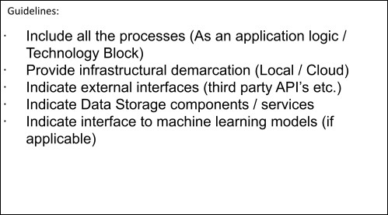
Example: Auto Ticket Classification using Flow Designer (ServiceNow School IT Helpdesk) Reference: https://docs.servicenow.com
5
Technology
IT Helpdesk Staff
Email Notification
Auto Category & Subcategory Assignment
Keyword Analysis
IT HELPDESK
Rule-based keyword classification | No external API or ML model
Description
Component
S.No
6
7
8
Flow Designer
Incident Workflow Table
Student / ServiceNow
Teacher IT Ticket
Form
4
3
2
1
SERVICENOW CLOUD PLATFORM
USER

ServiceNow Ticket/Form Interface
Interface used by students and teachers to create IT support tickets and enter issue details.
User Interface
1.

2. | Application Logic-1 | Automatically analyzes the ticket short description and identifies predefined issue keywords. | ServiceNow Flow Designer
3. | Application Logic-2 | Automatically assigns the appropriate Category and Subcategory based on the identified issue. | Flow Designer If / Else If Conditions and Update Record Actions
4. | Application Logic-3 | Sends an automated email notification to the caller after ticket creation and classification. | ServiceNow Flow Designer Send Email Action
5. | Database | Stores structured IT ticket information including caller, category, subcategory, description, state, assigned group and assigned user. | ServiceNow Incident Workflow / Custom Table
6. | Cloud Database | Not separately used in the project because the solution uses the ServiceNow platform for data storage. | ServiceNow Platform Database
7. | File Storage | Stores project/update-set export files when required for deployment or transfer. | ServiceNow Update Set XML / Local File Storage
8. | External API-1 | No external API is required for the ticket classification process. | Not Used
9. | External API-2 | No external API is required for the ticket classification process. | Not Used
10. | Machine Learning Model | The project uses predefined keyword-based Flow Designer conditions instead of a machine learning model. | Not Used — Rule-Based Classification
11. | Infrastructure (Server / Cloud) | The application is developed and executed within the ServiceNow platform.  Local Server Configuration: Not required Cloud Server Configuration: ServiceNow cloud instance | ServiceNow Cloud Platform

Table-2: Application Characteristics:

S.No | Characteristics | Description | Technology
1. | Open-Source Frameworks | The solution is implemented using ServiceNow Flow Designer and does not depend on external open-source frameworks. | ServiceNow Flow Designer
2. | Security Implementations | Access to ticket information and modification of records should be restricted to authorized users and appropriate ServiceNow roles. | ServiceNow Roles and Access Controls
3. | Scalable Architecture | The solution can be extended by adding new categories, subcategories, keywords, automation rules and additional workflow actions without redesigning the entire system. | ServiceNow Flow Designer
4. | Availability | The solution operates on the ServiceNow platform, allowing users to create and manage IT support tickets through the available ServiceNow environment. | ServiceNow Cloud Platform
5. | Performance | Automatic classification occurs when a ticket is created, reducing manual classification work and improving the efficiency of ticket routing. | ServiceNow Flow Designer Automation

References:
https://c4model.com/
https://developer.ibm.com/patterns/online-order-processing-system-during-pandemic/ https://www.ibm.com/cloud/architecture
https://aws.amazon.com/architecture
https://medium.com/the-internal-startup/how-to-draw-useful-technical-architecture-diagrams-2d20c9fda90d

PTou rapuotsoem /a Vticisailolyn classify school IT helpdesk tickets at creation using ServiceNow Flow Designer (no-code).

- CUSTOMER SEGMENT(S)
Whoisyour customer?
i.e. working parents of 0-5 y.o. kids
CS 6. CUSTOMER CONSTRAINTS CC
Whatconstraints prevent yourcustomers from taking action or limit their choices
of solutions? i.e. spending power, budget, no cash, network connection, available devices.
- AVAILABLE SOLUTIONS AS
Which solutions areavailable tothecustomers when they face the problem
Explore AS, differentiate
or need to get the job done? What have they tried in the past? What pros & cons do these solutions have? i.e. pen and paper is an alternative to digital notetaking

  - Students and teachers of the school who raise IT support tickets
(Wi-Fi, projector, password and slow-computer issues).
  - School IT helpdesk agents who receive, review and route these tickets.
  - Limited IT staff available to review every incoming request
  - manually.
  - Tickets must be classified correctly using standard Category and
  - Subcategory values (dependent choices).
  - The solution must be no-code and easy for the school to maintain. Users need confirmation that their request has been submitted. Process must handle growing request volume without extra effort.
  - Manual review: IT staff read each ticket and select the category and subcategory by hand.
Pros: human judgement. Cons: time-consuming, error-prone,
inconsistent and not scalable as requests increase.
  - Informing callers manually that a ticket has been created – adds extra effort for agents.
  - Our solution: Flow Designer automation classifies tickets on creation and sends an automatic email.

- JOBS-TO-BE-DONE / PROBLEMS
Which jobs-to-be-done(or problems)do youaddress for your customers? There could be more than one; explore different sides.
J&P
9. PROBLEM ROOT CAUSE
What is the real reason that thisproblem exists?
What is the back story behind the need to do this job?
RC 7. BEHAVIOUR BE
Whatdoes yourcustomer do to address the problem and get the job done?
Focus on J&P, tap into BE, understand RC
i.e. directly related: find the right solar panel installer, calculate usage and benefits;

i.e. customers have to do it because of the change in regulations.
indirectly associated: customers spend free time on volunteering work (i.e. Greenpeace)

- Classify each incident automatically when it is created (Network / Hardware / Access / Performance).
- Reduce manual effort for IT agents.
- Improve ticket routing efficiency and consistency.
- Notify the caller that the request has been submitted.
- Provide a no-code, easily maintainable solution.
- The school IT helpdesk receives many incident requests daily from students and teachers on common issues: network connectivity, hardware failures, account access and system performance.
- Categories are assigned manually by IT staff, so the process is
slow, error-prone and does not scale as the number of requests grows.
- Students/teachers create an IT support ticket in the Incident Workflow table and enter a Short Description (e.g. “WiFi not working in library”).
- IT agents currently open each ticket, identify the issue type and manually select the Category and Subcategory.
- Agents then inform the caller that the ticket has been created.

- TRIGGERS
What triggers customers to act? i.e. seeing their neighbour installing solar panels, reading about a more efficient solution in the news.
TR 10. YOUR SOLUTION SL
If you are working on an existing business, write down your current solution first, fill in the canvas, and check how much it fits reality.
- CHANNELS of BEHAVIOUR CH
  - ONLINE
Extract online & offline CH of BE
What kind of actions do customers take online? Extract online channels from #7

    - A student or teacher creates a new ticket (Record Created) with the Category field left empty – this triggers the flow.
•
Frequent Wi-Fi, projector, password and slow-computer issues reported by students and teachers.
If you are working on a new business proposition, then keep it blank until you fill in the canvas and come up with a solution that fits within customer limitations, solves a problem and matches customer behaviour.
Flow: “Auto Classify School IT Tickets” (ServiceNow Flow Designer)
    - Ticket created online in ServiceNow (Incident Workflow form).
    - Flow runs automatically; confirmation email sent to caller.

- EMOTIONS: BEFORE / AFTER
Howdo customers feelwhen theyface a problem or a job and afterwards?
•
•
EM •
Trigger: Record Created on Incident Workflow; condition: Category is Empty. If / Else If conditions check keywords in the Short Description:
WiFi/Network → Network / Wi-Fi; Projector → Hardware / Projector; Password/Login → Access / Forgot Password; Slow/Hanging → Performance /

  - OFFLINE
What kind of actions do customers take offline? Extract offline channels from #7 and use them for customer development.

i.e. lost, insecure > confident, in control - use it in your communication strategy & design.
Slow Computer. •

Before: unsure whether the request was received; agents spend time on manual review.
•
After: reassured by the confirmation email; tickets are classified correctly and agents
•
can focus on resolving.
    - Update Record sets Category and Subcategory; an automated email is sent to
    - the caller.
Maintained via Update Set (In progress → Complete, exportable as XML).
Offline (current process): IT agents manually review each request
    - and assign the category and subcategory.
Agents inform callers about ticket creation manually.

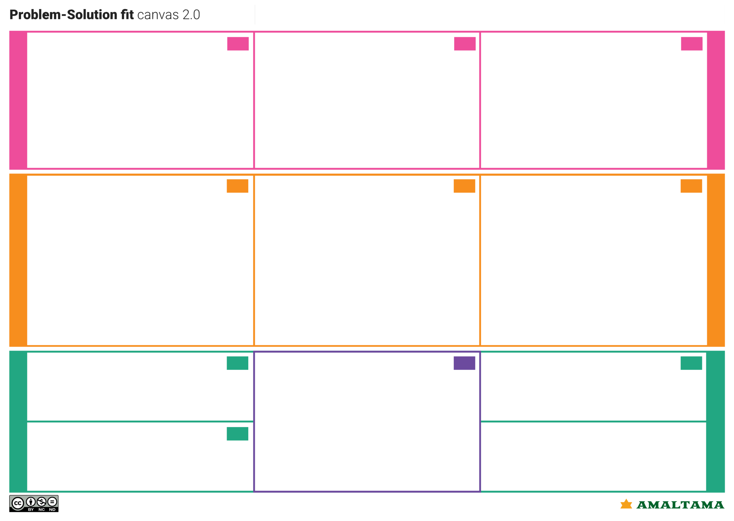
Identify strong TR & EM
Define CS, fit into CC
Focus on J&P, tap into BE, understand RC

Problem-Solution it canvas is licensed under a Creative Commons Attribution-NonCommercial-NoDerivatives 4.0 license Created by Daria Nepriakhina / Amaltama.com

Project Design Phase Problem – Solution Fit Template

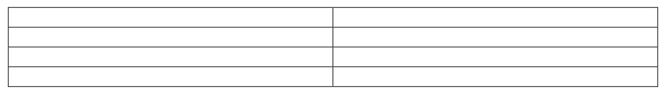
Date Team ID
Project Name
30 September 2026
SWTID-2026-7613
Auto Ticket Classification using Flow Designer

Maximum Marks 2Marks

Problem – Solution Fit Template:
The Problem-Solution Fit simply means that you have found a problem with your customer and that the solution you have realized for it actually solves the customer’s problem. It helps entrepreneurs, marketers and corporate innovators identify behavioral patterns and recognize what would work and why

Purpose:
      - Solve complex problems in a way that fits the state of your customers.
      - Succeed faster and increase your solution adoption by tapping into existing mediums and
channels of behavior.
      - Sharpen your communication and marketing strategy with the right triggers and messaging.
      - Increase touch-points with your company by finding the right problem-behavior fit and
building trust by solving frequent annoyances, or urgent or costly problems.

Understand the existing situation in order to improve it for your target group.

Template:

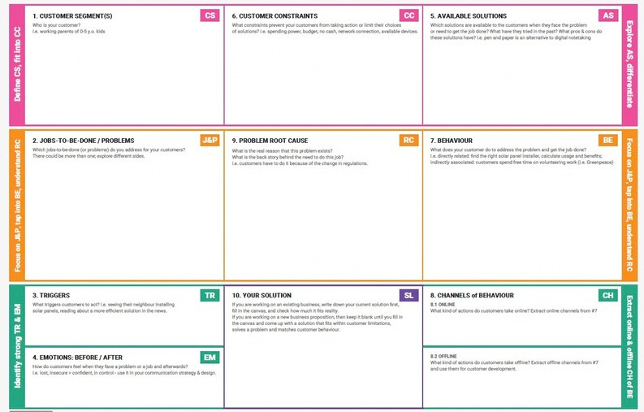
- Students and teachers who raise IT support tickets (Wi-Fi, projector, password, slow computer).
- School IT helpdesk agents who review and route tickets.

- Limited IT staff to review every request manually.
- Standard, dependent Category/Subcategory values are required.
- Solution must be no-code and easy to maintain.
- Callers need confirmation that the request was submitted.

- Manual review: agents read each ticket and pick the category by hand (time-consuming, error-prone, not scalable).
- Manual caller notification adds extra effort.
- Ours: Flow Designer auto-classifies and emails the caller.

  - Classify each incident automatically on creation (Network / Hardware / Access / Performance).
  - Reduce manual effort for IT agents.
  - Improve ticket routing efficiency.
  - Notify the caller of submission.
  - Keep the solution no-code and maintainable.

- The IT helpdesk receives many daily requests from students and teachers on network, hardware, access and performance issues.
- Categories are assigned manually by IT staff, which is slow, error-prone and does not scale as request volume grows.

- Student/teacher creates a ticket in the Incident Workflow table with a Short Description (e.g. “WiFi not working in library”).
- Agents currently identify the issue type and manually select Category and Subcategory.
- Agents then inform the caller.

  - New ticket created with Category empty (Record Created) triggers the flow.

  - Ticket created online in ServiceNow; flow runs and emails the caller.

  - Before: unsure if request was received; manual review workload.
  - After: reassured by confirmation email; tickets classified correctly.

Flow: “Auto Classify School IT Tickets”
- Trigger: Record Created on Incident Workflow; condition Category is Empty.
- If / Else If conditions check keywords in Short Description:
- WiFi → Network/Wi-Fi; Projector → Hardware/Projector; Password/Login →
Access/Forgot Password; Slow/Hanging → Performance/Slow Computer.
- Category and Subcategory updated; automated email sent to the caller.
- Maintained via Update Set (In progress → Complete, exportable as XML).

- Current process: agents manually review requests, assign the category and inform callers.

References:
- https://www.ideahackers.network/problem-solution-fit-canvas/
- https://medium.com/@epicantus/problem-solution-fit-canvas-aa3dd59cb4fe

Project Design Phase Proposed Solution Template

Date | 30 September 2026
Team ID | SWTID-2026-7613
Project Name | Auto Ticket Classification using Flow Designer
Maximum Marks | 2 Marks

Proposed Solution Template:
Project team shall fill the following information in the proposed solution template.

S.No. | Parameter | Description
1. | Problem Statement (Problem to be solved) | The school IT helpdesk receives many requests from students and teachers (Wi-Fi, projector, password and slow computer issues). IT staff review each ticket manually to assign a category, which is  time-consuming and inefficient.
2. | Idea / Solution description | A ServiceNow Flow Designer flow, Auto Classify School IT Tickets, runs when an Incident Workflow record is created with an empty Category. It checks keywords in the Short Description, sets Category and Subcategory, and emails the caller.
3. | Novelty / Uniqueness | A no-code, easily maintained solution using If / Else If keyword rules and dependent Category and Subcategory fields, with an automatic confirmation email. No scripting or machine learning is used.
4. | Social Impact / Customer Satisfaction | Tickets are classified consistently at creation, reducing manual effort for IT agents and improving routing. Callers receive an automatic email confirming their request has been submitted.
5. | Business Model (Revenue Model) | Not applicable - internal school IT helpdesk automation built on ServiceNow. No revenue model is defined in the project document.
6. | Scalability of the Solution | Easy to maintain, since keyword rules can be added in Flow Designer. Future scope: assignment automation, SLA tracking and predictive intelligence.


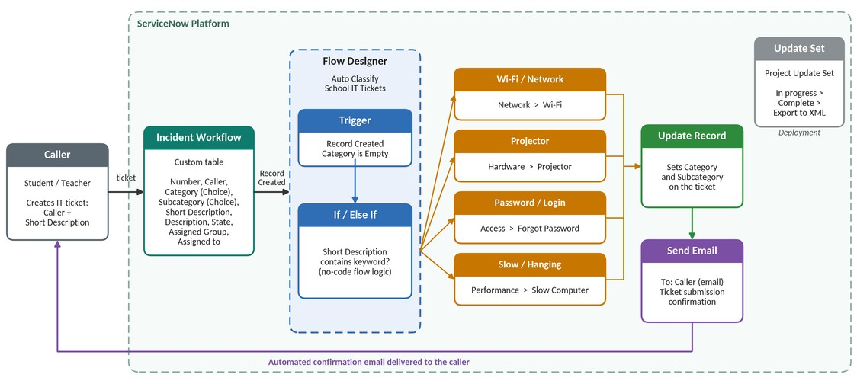
Project Design Phase Solution Architecture

Figure 1: Architecture and data flow of the Auto Ticket Classification solution
Reference:Project document – Auto Ticket Classification using Flow Designer (ServiceNow)
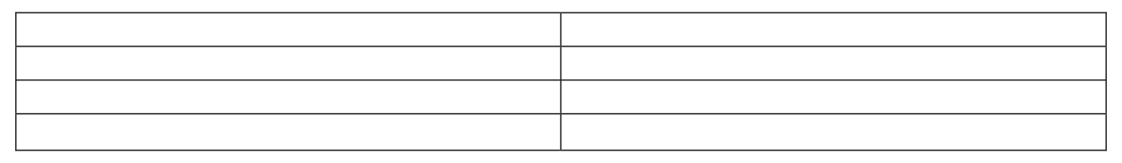
Date
Team ID Project Name
Maximum Marks
30 September 2026
4 Marks
Auto Ticket Classification using Flow Designer
SWTID-2026-7613

Solution Architecture:
Solution architecture is a complex process – with many sub-processes – that bridges the gap between business problems and technology solutions. Its goals are to:


- Find the best tech solution to solve existing business problems.
- Describe the structure, characteristics, behavior, and other aspects of the software to project stakeholders.
- Define features, development phases, and solution requirements.
- Provide specifications according to which the solution is defined, managed, and delivered.
Solution Architecture Diagram:

Project Planning Phase
Project Planning Template (Product Backlog, Sprint Planning, Stories, Story Points)

Date: 30 September 2026
Team ID: SWTID-2026-7065
Maximum Marks: 5 Marks

Project Name: Auto Ticket Classification using Flow Designer Team Size: 5 Team Leader: Kirubakaran S

Product Backlog, Sprint Schedule, and Estimation (4 Marks)
Use the below template to create product backlog and sprint schedule.

Sprint | Functional Requirement (Epic) | User Story Number | User Story / Task | Story Points | Priority | Team Members
Sprint-1 | Requirement Analysis & Planning | USN-1 | As a project team, we can document the business use case and requirements for auto ticket classification. | 2 | High | Kirubakaran S
Sprint-1 | Update Set Creation | USN-2 | As a developer, I can create the Project Update Set and make it current. | 1 | High | Dinesh B
Sprint-1 | Custom Table Creation | USN-3 | As a developer, I can create the Incident WorkFlow table with Auto Number. | 2 | High | Sadasivakrishnan R S
Sprint-1 | Field Creation and Data Type Configuration | USN-4 | As a developer, I can create the ticket fields and choice lists with correct data types. | 2 | High | Sadasivakrishnan R S
Sprint-2 | Category and Subcategory Dependency | USN-5 | As a user, I can see Subcategory options based on the selected Category. | 2 | High | Vijay Ragavan S
Sprint-2 | Flow Designer Auto Classification | USN-6 | As an IT agent, I get tickets classified automatically by a flow triggered when a ticket is created. | 3 | High | Dinesh B
Sprint-2 | Wi-Fi Issue Classification | USN-7 | As a student, my Wi-Fi/Network ticket is set to Network > Wi-Fi. | 2 | High | Kirubakaran S
Sprint-2 | Projector Issue Classification | USN-8 | As a teacher, my Projector ticket is set to Hardware > Projector. | 2 | High | Dinesh B
Sprint-3 | Password Issue Classification | USN-9 | As a user, my Forgot Password ticket is set to Access > Forgot Password. | 2 | Medium | Sadasivakrishnan R S
Sprint-3 | Slow Computer Classification | USN-10 | As a user, my Slow Computer ticket is set to Performance > Slow Computer. | 2 | Medium | Vijay Ragavan S
Sprint-3 | Email Notification | USN-11 | As a caller, I will receive a confirmation email once my ticket is created. | 2 | High | Kirubakaran S
Sprint-4 | Testing and Validation | USN-12 | As a tester, I can validate the data and run the Wi-Fi and Projector test scenarios. | 2 | High | Ragulraj H
Sprint-4 | Deployment and Final Documentation | USN-13 | As a developer, I can complete and export the update set and finalize the documentation. | 2 | High | Kirubakaran S

Source: Original uploaded Project Planning Template.

Project Tracker, Velocity & Burndown Chart: (4 Marks)

Sprint | Total Story Points | Duration | Sprint Start Date | Sprint End Date (Planned) | Story Points Completed (as on Planned End Date) | Sprint Release Date (Actual)
Sprint-1 | 20 | 6 Days | 02 Feb 2026 | 07 Feb 2026 | 20 | 07 Feb 2026
Sprint-2 | 20 | 6 Days | 09 Feb 2026 | 14 Feb 2026 | 20 | 14 Feb 2026
Sprint-3 | 20 | 6 Days | 16 Feb 2026 | 21 Feb 2026 | 20 | 21 Feb 2026
Sprint-4 | 20 | 6 Days | 23 Feb 2026 | 28 Feb 2026 | 20 | 28 Feb 2026

Velocity:
Imagine we have a 10-day sprint duration, and the velocity of the team is 20 (points per sprint). Let’s calculate the team’s average velocity (AV) per iteration unit (story points per day)
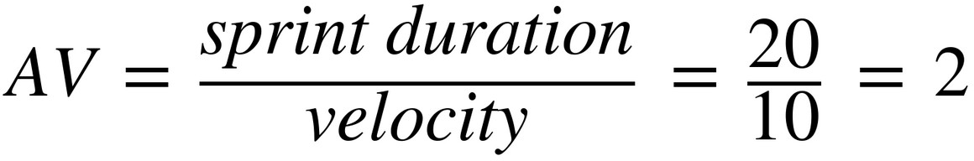

Burndown Chart:

A burndown chart is a graphical representation of the work remaining versus time. It is used to track the progress of the Auto Ticket Classification using Flow Designer project across different sprints.

For this project, the burndown chart represents the completion of tasks related to:
- Requirement Analysis and Planning
- ServiceNow Backend Configuration
- Category and Subcategory Dependency
- Flow Designer Automation
- Email Notification
- Testing and Validation
- Deployment and Documentation

The chart shows how the remaining Story Points decrease as the team completes the planned tasks during each sprint.

References:

https://www.atlassian.com/agile/project-management

https://www.atlassian.com/agile/tutorials/sprints

https://www.atlassian.com/agile/tutorials/epics

https://www.atlassian.com/agile/tutorials/burndown-charts

https://www.atlassian.com/agile/project-management/estimation

A Sprint fixed period or duration in which a team works to complete a set of tasks
An Epic is a big task or project that is too large to complete in one sprint. It is broken down into smaller tasks (stories) that can be completed over multiple sprints.
A Story is a small task . It is part of an Epic.
A Story Point is a number that represents how much effort a story takes to complete. (usually in form of Fibonacci series)
- Very Easy task
- Normal task
- Moderate task
5- Difficult task

Storypoint -5 (1,2,3,5)

Sprint 1
Requirement Analysis & Planning (Epic 1)
Analyzing Manual Ticket Classification Process(USN1) 3 Identifying Business Requirements(USN2) 2
Defining Ticket Classification Rules(USN3) 3
Defining Notification and Data Storage Requirements(USN4) 2 ServiceNow Backend Configuration (Epic 2)
Creating Incident Workflow Table(USN5) 3 Configuring Ticket Fields(USN6) 3 Configuring Field Data Types(USN7) 2 Configuring Choice Values(USN8) 2
Total Story Point in Sprint 1= 3+2+3+2+3+3+2+2=20

Sprint 2
Category and Subcategory Dependency (Epic 3) Configuring Category as Dependent Field(USN9) 3

Configuring Subcategory Dependency(USN10) 3 Mapping Wi-Fi to Network(USN11) 1
Mapping Projector to Hardware(USN12) 1 Mapping Forgot Password to Access(USN13) 1 Mapping Slow Computer to Performance(USN14) 1
Flow Designer Automation (Epic 4)
Creating Auto Classify School IT Tickets Flow(USN15) 2 Configuring Record Created Trigger(USN16) 2 Checking Whether Category is Empty(USN17) 1 Detecting Wi-Fi/Network Keywords(USN18) 3 Detecting Projector/Hardware Keywords(USN19) 2
Total Story Point in Sprint 2= 3+3+1+1+1+1+2+2+1+3+2=20

Sprint 3
Flow Designer Automation (Epic 4 - Continued) Detecting Password/Login Keywords(USN20) 3 Detecting Slow/Hanging Keywords(USN21) 3
Automatically Updating Category and Subcategory(USN22) 5 Email Notification (Epic 5)
Configuring Send Email Action(USN23) 3 Sending Confirmation Email to Caller(USN24) 3
Configuring Email Subject and Ticket Confirmation Message(USN25) 3 Total Story Point in Sprint 3= 3+3+5+3+3+3=20

Sprint 4
Testing and Validation (Epic 6)
Testing Wi-Fi Ticket Classification(USN26) 2 Testing Projector Ticket Classification(USN27) 2

Testing Password/Login Ticket Classification(USN28) 2 Testing Slow Computer Ticket Classification(USN29) 2 Verifying Category and Subcategory Values(USN30) 2 Verifying Email Notification(USN31) 2
Deployment and Documentation (Epic 7) Completing the Update Set(USN32) 1 Exporting the Update Set(USN33) 1
Preparing Final Project Documentation(USN34) 3 Validating Complete End-to-End Workflow(USN35) 3
Total Story Point in Sprint 4= 2+2+2+2+2+2+1+1+3+3=20

Total Story Points
Sprint 1 = 20
Sprint 2 = 20
Sprint 3 = 20
Sprint 4 = 20

Velocity= Total Story Points Completed/ Number of Sprints Total story Points= 20+20+20+20=80
No of Sprints= 4
Velocity =80/4
20(Story Points per Sprint)
Your team’s velocity is 20 Story Points per Sprint.

Project Development Phase Model Performance Test

Date | 30 September 2026
Team ID | SWTID-2026-7613
Project Name | Auto Ticket Classification using Flow Designer
Maximum Marks | 10 Marks

Model Performance Testing:
Project team shall fill the following information in model performance testing template.

S.No. | Parameter | Values | Screenshot
1. | Metrics | Regression Model: Not applicable (rule-based solution, no ML model).  Classification Model: Rule-based keyword classification using Flow Designer (If / Else If on Short Description). Confusion Matrix, Accuracy Score and Classification Report: Not applicable. Verified with 2 test scenarios (Wi-Fi, Projector) - both classified as expected. | 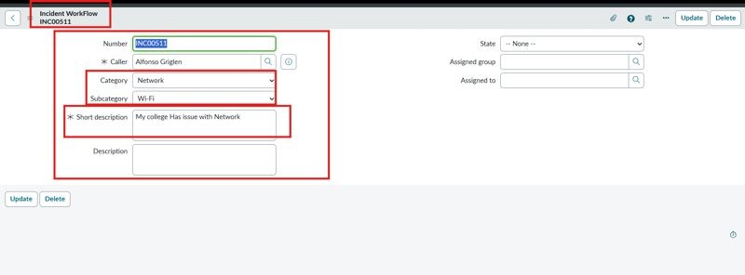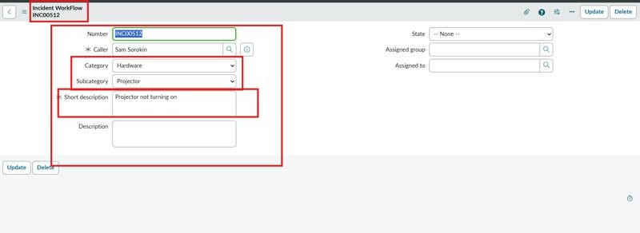
2. | Tune the Model | Hyperparameter Tuning - Not applicable (no ML model). Validation Method - Functional testing with sample tickets; confirmation email checked in System Logs > Emails. | 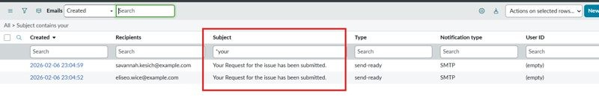

Functional & Performance Testing Template
Model Performance Test

Date | 30 September 2026
Team ID | SWTID-2026-7613
Project Name | Auto Ticket Classification using Flow Designer
Maximum Marks

Test Scenarios & Results

Test Case ID | Scenario (What to test) | Test Steps (How to test) | Expected Result | Actual Result | Pass/Fail
FT-01 | Short Description keyword  - Wi-Fi / Network (e.g., "WiFi not working in library") | Enter Caller and Short Description; save and reload the form | Category = Network, Subcategory = Wi-Fi | Network / Wi-Fi set | Pass
FT-02 | Short Description keyword  - Projector (e.g., "Projector not turning on") | Enter Caller and Short Description; save and reload the form | Category = Hardware, Subcategory = Projector | Hardware / Projector set | Pass
FT-03 | Email notification to the caller | Search the subject in System Logs > Emails and use Preview Mail | Confirmation email is sent to the caller | Email sent | Pass
FT-04 | Category and Subcategory dependency | Open the Incident Workflow form and select a Category | Subcategory choices depend on the selected Category | Choices filtered | Pass
PT-01 | Response Time Test | Use a timer to check content generation time | Should be under 3 seconds | Not tested | N/A
PT-02 | API Speed Test | Send multiple API calls at the same time | API should not slow down | Not tested | N/A
PT-03 | File Upload Load Test (e.g., PDFs) | Upload multiple PDFs and check processing | Should work smoothly without crashing | Not tested | N/A

Project Development Phase Model Performance Test

Date | 30 September 2026
Team ID | SWTID-2026-7613
Project Name | Auto Ticket Classification using Flow Designer
Maximum Marks | 10 Marks

Model Performance Testing:
Project team shall fill the following information in model performance testing template.

S.No. | Parameter | Values | Screenshot
1. | Metrics | Regression Model: Not applicable (rule-based solution, no ML model).  Classification Model: Rule-based keyword classification using Flow Designer (If / Else If on Short Description). Confusion Matrix, Accuracy Score and Classification Report: Not applicable. Verified with 2 test scenarios (Wi-Fi, Projector) - both classified as expected.
2. | Tune the Model | Hyperparameter Tuning - Not applicable (no ML model). Validation Method - Functional testing with sample tickets; confirmation email checked in System Logs > Emails.

Project Development Phase Model Performance Test

Date | 30 September 2026
Team ID | SWTID-2026-7613
Project Name | Auto Ticket Classification using Flow Designer
Maximum Marks

Model Performance Testing:
Project team shall fill the following information in model performance testing template.

S.No. | Parameter | Screenshot / Values
1. | Data Rendered | Ticket records are stored in the custom Incident Workflow table (Number, Caller, Category, Subcategory, Short Description, Description, State, Assigned Group, Assigned to).
2. | Data Preprocessing | No data preprocessing required. The flow reads the Short Description of each new ticket and matches predefined keywords.
3. | Utilization of Data Filters | 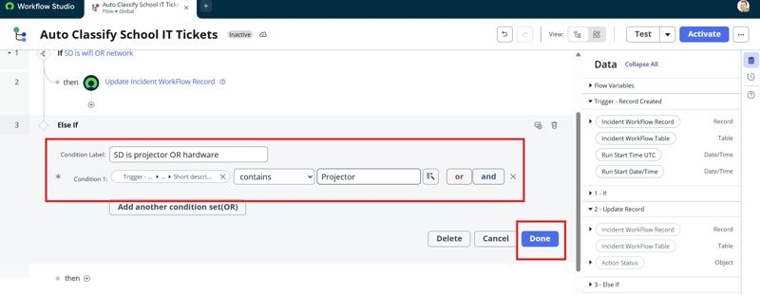  Trigger condition: Category is Empty. If / Else If conditions: Short Description contains WiFi / Network, Projector, Password / Login or Slow / Hanging.
4. | DAX Queries Used | Not applicable - no-code Flow Designer solution; no DAX queries are used.
5. | Dashboard design | No of Visualizations / Graphs - Not applicable (no dashboard in this project)
6 | Report Design | No of Visualizations / Graphs - Not applicable (no report in this project)

Project Development Phase Model Performance Test

Date | 30 September 2026
Team ID | SWTID-2026-7613
Project Name | Auto Ticket Classification using Flow Designer
Maximum Marks

Model Performance Testing:
Project team shall fill the following information in model performance testing template.

S.No. | Parameter | Values | Screenshot
1. | Model Summary | ServiceNow Flow Designer automation (Auto Classify School IT Tickets) to classify school IT tickets using the custom Incident Workflow table with Choice and Reference fields.  Note: When a ticket is created with an empty Category, the flow checks the Short Description for keywords, updates Category and Subcategory, and sends a confirmation email to the caller. | 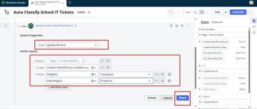
2. | Accuracy | Training Accuracy - Not applicable (rule-based classification, no ML model)  Validation - 2 of 2 test scenarios (Wi-Fi, Projector) classified as expected
3. | Confidence Score (Only Yolo Projects) | Not applicable - not a YOLO project. Classes assigned by the flow (rule-based, no confidence score): Network / Wi-Fi, Hardware  / Projector, Access / Forgot Password, Performance / Slow Computer.

Project Development Phase Performance Test

Date | 30 September 2026
Team ID | SWTID-2026-7613
Project Name | Auto Ticket Classification using Flow Designer
Maximum Marks

Model Performance Testing:
Project team shall fill the following information in model performance testing template.

S.No. | Parameter | Screenshot / Values
1. | Data Rendered | Ticket records are stored in the custom Incident Workflow table (Number, Caller, Category, Subcategory, Short Description, Description, State, Assigned Group, Assigned to).
2. | Data Preprocessing | No data preprocessing required. The flow reads the Short Description of each new ticket and matches predefined keywords.
3. | Utilization of Filters | Trigger condition: Category is Empty. If / Else If conditions: Short Description contains WiFi / Network, Projector, Password / Login or Slow / Hanging.
4. | Calculation fields Used | Not applicable - no calculated fields; Category and Subcategory are set by Update Record actions in Flow Designer.
5. | Dashboard design | No of Visualizations / Graphs - Not applicable (no dashboard in this project)
6 | Story Design | No of Visualizations / Graphs - Not applicable (no story in this project)

User Acceptance Testing (UAT) Template

Date | 30 September 2026
Team ID | SWTID-2026-7613
Project Name | Auto Ticket Classification using Flow Designer
Maximum Marks

Project Overview:
Project Name: Auto Ticket Classification using Flow Designer
Project Description: Auto-classification of school IT tickets using ServiceNow Flow Designer
Project Version: [Version Number] Testing Period: [Start Date] to [End Date] Testing Scope:
Automatic Category / Subcategory classification from Short Description; email notification to caller Classify at creation; dependent Category and Subcategory; automated confirmation email

Testing Environment:
URL/Location: ServiceNow instance - Incident Workflow table and Flow Designer
Credentials (if required): [Username/Password]

Test Cases:

Test Case ID | Test Scenario | Test Steps | Expected Result | Actual Result | Pass/Fail
TC-001 WiFi keyword ("WiFi not working in library") |  | - Enter Caller  - Enter Short Description  - Save and reload the form | Network / Wi-Fi set; email sent to caller | Network / Pass Wi-Fi set;  email sent to caller
TC-002 Projector keyword ("Projector not turning on") |  | - Enter Caller  - Enter Short Description  - Save and reload the form | Hardware / Projector set; email sent to caller | Hardware / Pass  Projector set; email sent to caller

Bug Tracking:

Bug ID | Bug Description | Steps to reproduce | Severity | Status | Additional feedback
BG-001 | [Describe the issue or  bug encountered | [Step 1]  [Step 2]  [Step 3] | [Low/Medi um/High] | [Open/In Progress/ | [Any additional comments or

 | ] |  |  | Closed] | feedback]
... | ... | ... | ... | ... | ...

Sign-off:
Tester Name: [Name of Tester] Date: [Date of Test Completion] Signature: [Tester's Signature] Notes:
- Ensure that all test cases cover both positive and negative scenarios.
- Encourage testers to provide detailed feedback, including any suggestions for improvement.
- Bug tracking should include details such as severity, status, and steps to reproduce.
- Obtain sign-off from both the project manager and product owner before proceeding with deployment.

Acceptance Testing

UAT Execution & Report Submission

Date | 30 September 2026
Team ID | SWTID-2026-7613
Project Name | Auto Ticket Classification using Flow Designer
Maximum Marks | 4 Marks

Purpose of Document
The purpose of this document is to briefly explain the test coverage and open issues of the Auto Ticket Classification using Flow Designer project at the time of the release to User Acceptance Testing (UAT).

Defect Analysis
This report shows the number of resolved or closed bugs at each severity level, and how they were resolved
Resolution | Severity 1 | Severity 2 | Severity 3 | Severity 4 | Subtotal
By Design | - | - | - | - | -
Duplicate | - | - | - | - | -
External | - | - | - | - | -
Fixed | - | - | - | - | -
Not Reproduced | - | - | - | - | -
Skipped | - | - | - | - | -
Won't Fix | - | - | - | - | -
Totals | - | - | - | - | -

Test Case Analysis
This report shows the number of test cases that have passed, failed, and untested
Section | Total Cases | Not Tested | Fail | Pass
Wi-Fi Classification | 1 | 0 | 0 | 1
Projector Classification | 1 | 0 | 0 | 1
Password Classification | 1 | 1 | 0 | 0
Slow Computer Classification | 1 | 1 | 0 | 0

Email Notification | 2 | 0 | 0 | 2
Category-Subcategory Dependency | 1 | 0 | 0 | 1
- | - | - | - | -

